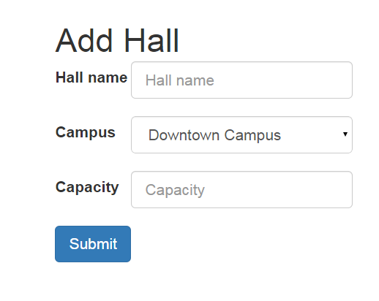

1. Hall Name Field

* Description: This is where the staff input name for the new hall.
  + Action: Staff inputs the name of the hall.

1. Campus Field
   * Description: This is where the staff selects the Campus of the new hall.
   * Action: Staff clicks the campus of the new hall.
2. Capacity Field

* Description: This is where the staff inputs the capacity of the new hall
  + Action: Staff inputs the capacity of the new hall.

1. Submit
   * Description: Button
   * Action: Redirects to addHall.php to add it to database